|  |
| --- |
| NREL |
| Dehumidifier Retrofit with VOLTTRONTM - User Guide |
|  |
|  |
| **Kathleen Gegner** |
| **12/12/2014** |

|  |
| --- |
| Contact info, should you have questions: kathleen.gegner@outlook.com or kathleen.gegner@huskers.unl.edu |

Table of Contents

1.0 Document Overview 2

2.0 BeagleBone Black Overview 3

3.0 VOLTRRONTM Overview 3

4.0 Configuring the BeagleBone Black 4

4.1 Update the BeagleBone Black Image 4

4.2 Establish Internet Connectivity 5

Option 1: Using NREL Wireless 5

Option 2: Using Non-NREL Network 5

4.3 Setup Super User Password (allows login as a root user) 5

4.4 Install PyBBIO and Python dependencies 5

5.0 Installing VOLTTRONTM 6

5.1 Using NREL Wireless 6

5.2 Using Non-NREL Network 7

6.0 Interacting with the BeagleBone 8

6.1 Connecting to BeagleBone with External Monitor, Keyboard, and Mouse 8

6.2 Connecting to BeagleBone from Laptop with USB (SSH) 8

6.3 Connecting to BeagleBone from Laptop in Web Browser 8

Option 1: Your BeagleBone is directly connected to your laptop via USB 9

Option 2: Your BeagleBone is wirelessly connected to the same network as your computer 9

6.4 Transferring Files between Laptop and BeagleBone 10

7.0 Developing Agents and Using VOLTTRONTM 10

8.0 Experiment Guide 11

8.1 Project Overview 11

8.2 (Pre- Experimentation) Create Services That Run Automatically at Boot 12

Create Service that Sets GPIO Pins Low 12

Create Service that Updates Date and Time 13

8.3 Hardware Setup 13

8.4 Transfer Code for Agents to BeagleBone and Install the Agents 15

8.5 Run Experiment 15

# Document Overview

This document is a user guide for how to retrofit a dehumidifier with a BeagleBone Black microcomputer to enable remote control of the appliance from a laptop, smartphone, or tablet, and allow for energy management or demand response on it. The intent is to provide sufficient information for this setup to be replicated in other appliances, and provide a blueprint for how VOLTTRONTM can be used in future research.

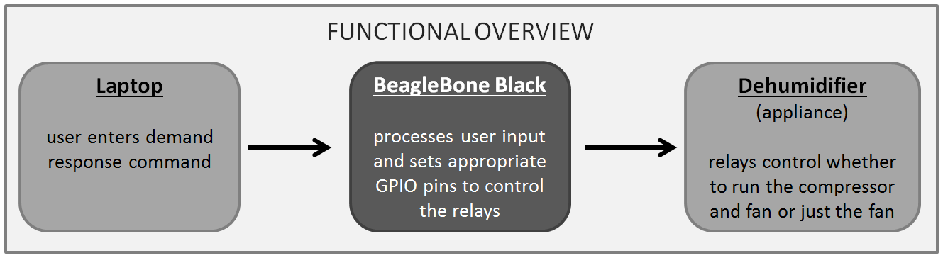

A general overview of a BeagleBone Black microcomputer and VOLTTRONTM is provided, as well as information about how to configure the BeagleBone, install VOLTTRON, how to interact with both, and lastly the steps required to actually control the dehumidifier.

The following table provides information about all the equipment used.

|  |  |  |  |
| --- | --- | --- | --- |
| Component Type | Description | Model/Version | Technical Details |
| Power supply | Connects BeagleBone to wall outlet | ----- | 120 VAC/5VDC, 2A switch mode power supply |
| Microcomputer | Link between internet and appliances | BeagleBone Black, May 2014 | ----- |
| Laptop | Controls BeagleBone with user commands | Any | ----- |
| Relays | Controlled by BeagleBone and operate compressor and fan of dehumidifier | Carlo Gavazzi | 3-32 VDC input, up to 240 VAC output |
| Wi-Fi Dongle | Connects BeagleBone to internet | Logic Supply UWN200 Compact USB Wi-Fi Adapter | 4 inch antenna |
| Wires  (BeagleBone to relays) | P9.12 to Relay1 is blue  P9.14 to Relay2 is green  P9.1 to both relays is black | ----- | 22 AWG |
| Wires  (relays to dehumidifier) | + terminal of Relay 1 is blue  + terminal of Relay 2 is green  - terminal of Relays 1 & 2 is black | ----- | 18 AWG |

Note: I created a version of the VOLTTRON agents (software) that you can run on your computer to play around with them. I removed the code specific to the BeagleBone. You can find that code and the commands required to install and run them on GitHub and the Y drive.

# BeagleBone Black Overview

The BeagleBone Black is a palm sized microcomputer. Its purpose in this project was to create a bridge between the dehumidifier and cloud, in order to allow remote control by a laptop. Commands at the laptop initiated demand response. In the future an energy manager would replace the laptop.

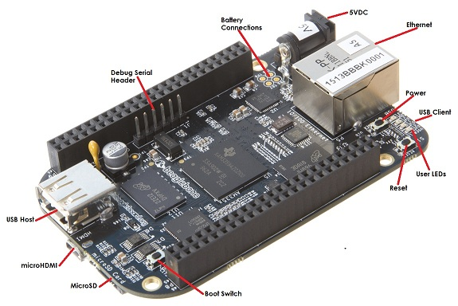

Throughout this document, the symbol ‘>>’ is used to designate what text YOU should type into the command line. Do not type ‘>>” when you enter the command.

**Processor:**

1 GHz

**Video out:**

HDMI

**DRAM:**

512 MB DDR3L 800 MHz

**Flash:**

4GB eMMC, uSD

Perhaps some helpful references:

* BeagleBone’s ‘Getting Started’ [website](http://beagleboard.org/getting-started).
* Logic Supply’s BeagleBone Tutorial’s [website.](http://inspire.logicsupply.com/)
* BeagleBone [wiki page](http://elinux.org/BeagleBoneBlack).
* Network folder has some more instructions too

# VOLTRRONTM Overview

VOLTTRONTM is an open-source software platform created at Pacific Northwest National Laboratory for the purpose of linking devices together for energy management. VOLTTRONTM is composed of software agents connected by a message bus. Each agent performs a specific function, such as getting weather information, reading an electric meter for power consumption, or controlling an appliance. Agents publish any pertinent information to a message bus, which can then be read by any other agent that needs that information. For example, two agents could each read energy consumption from two separate household appliances. A third agent could collect those energy readings from the message bus, and then sum them together to get total energy use. Thus, the message bus links all agents and allows for the exchange of information and/or centralized control.

In the figure below, the green boxes are agents that perform specific actions and communicate through the message bus. Creation of agents is left to the user, as only a few example agents are included in the VOLTTRONTM platform. Red boxes are cloud-based databases and streams for weather information, electricity prices, or data storage for the VOLTTRONTM message bus. The dark blue boxes, are actual devices, like electric meters or building systems that either provide information or are being controlled. Lastly, the light blue box is the VOLTTRONTM message bus which links all agents.

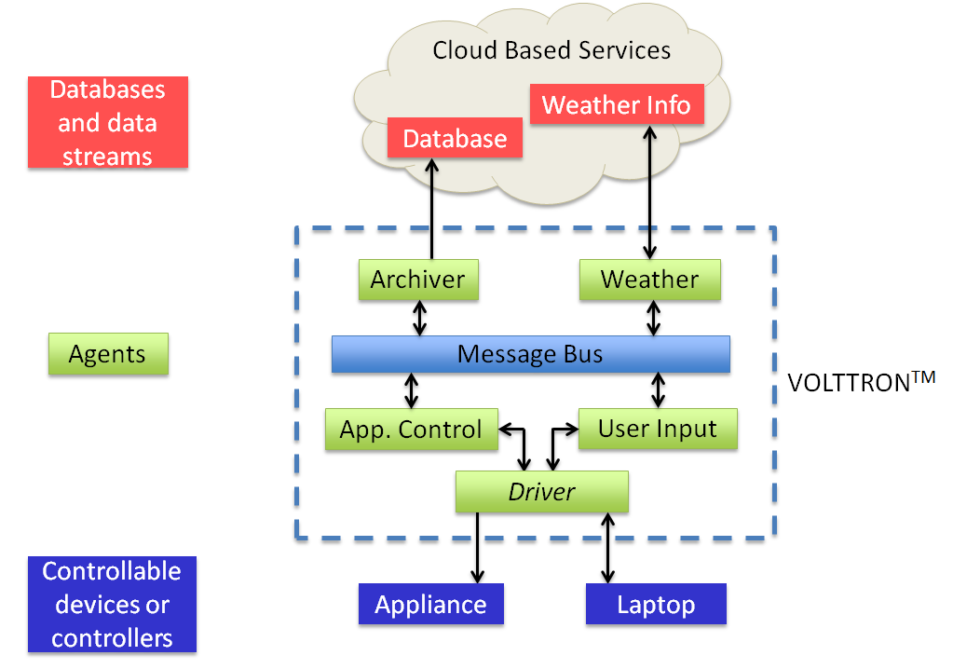

VOLTTRONTM block diagram.

# Configuring the BeagleBone Black

## Update the BeagleBone Black Image

Connect an external HDMI monitor to the BeagleBone, as well as an external USB port with a mouse and keyboard plugged into it. Supply power to the 5V DC barrel port, with a 5V DC 2A power supply.

1. Check the image version loaded to your BeagleBone Black. To do this, type the following into the LX terminal (exclude ‘>>’):

>> uname -a

As of this writing (12/12/14), the latest BeagleBone Black image was 3.18.13-bone50 updated in May 2014. If a newer image exists it can be found [here](http://beagleboard.org/latest-images) (see next step).

1. If the image is not up to date, follow the instructions at [this website](http://beagleboard.org/getting-started#update) to update it, but consult the text in red, below, before executing steps 2 and 4:

** In Step #2, check whether you are running 32 or 64 bit version of Windows. To do this:

This is for computers running Windows Vista or Windows 7

Click the **Start** button, right click **Computer**, and the click **Properties**.

Check next to **System type** for either “64-bit Operating System” or “32-bit Operating System”

Note: The edition of Windows Vista or Windows 7 you're running is displayed under **Windows edition** near the top of the window.

Download the correct version (32 or 64 bit) of 7-zip accordingly.

** In Step #4 the Win32DiskImager binary file can be found [here](http://sourceforge.net/projects/win32diskimager/files/Archive/Win32DiskImager-0.9.5-binary.zip/download) or in the network folder.

## Establish Internet Connectivity

Connect an external HDMI monitor to the BeagleBone, as well as an external USB port with a mouse, keyboard, and Wi-Fi dongle plugged into it. Supply power to the 5V DC barrel port, with a 5V DC 2A power supply.

### Option 1: Using NREL Wireless

1. Connect to NREL Wireless network

Click start 🡪 Internet 🡪 Wicd Network Manager

Under the network called NREL_Wireless…

Select “Automatically connect to this network” and click “Connect”

1. Open an internet browser

* Try to open any website besides Google
* An NREL authentication window should open
* Enter your credentials
* Verify that you have internet access by trying to open another website beside Google

### Option 2: Using Non-NREL Network

1. Connect to your non-NREL network

Click start 🡪 Internet 🡪 Wicd Network Manager

Under the network you want to use…

Select “Automatically connect to this network”

Click “Properties” and enter your password or security key into the area that says “key”

Click “OK” and then “Connect”

1. Open a web browser and try to go to a website besides Google

## Setup Super User Password (allows login as a root user)

Use the external monitor setup with keyboard, mouse, and Wi-Fi dongle attached, and turn on the BeagleBone. Open an LX terminal window.

>> sudo passwd root

Enter new UNIX password: >> root (nothing will appear)

Retype new UNIX password: >> root (nothing will appear)

psswd: password updated successfully

## Install PyBBIO and Python dependencies

PyBBIO is a hardware IO that allows you to easily control GPIO pins. For example to set a GPIO pin high, you would use PyBBIO’s built in function, digitalWrite(GPIO_whatever, HIGH), rather than anything more complicated. If you have used Arduino’s built in functions, this is a similar idea, but on the BeagleBone. For more information on PyBBIO and its capabilities visit the [wiki](https://github.com/alexanderhiam/PyBBIO/wiki).

1. Change to root user

su –

password: root

1. Install Python dependencies

>> apt-get update && apt-get install python-serial python-setuptools python-dev python- smbus python-pip

1. Install PyBBIO

>> pip install PyBBIO

# Installing VOLTTRONTM

You have two options for installing VOLTTRON on the BeagleBone. You may install it using NREL wireless or by using a non-NREL network at home (or hotspot at work). You cannot install VOLTTRON using LabAirNet or by using a computer’s hardwired NREL network connection through the USB port.

## Using NREL Wireless

Using NREL Wireless assumes you have setup an account with the computer services folks. If you haven’t done that, do so.

The BeagleBone Black should be connected to an external monitor, external USB hub with Wi-Fi dongle, keyboard, and mouse plugged in. Once everything is connected, power should be supplied to the 5V DC barrel port with a 5V DC, 2A power supply.

1. Verify you are connected to NREL wireless.

start 🡪 Internet 🡪 Wicd Network Manager

1. Open an internet browser

* Try to open any website besides Google
* An NREL authentication window should open
* Enter your credentials
* Verify that you have internet access by trying to open another website beside Google

1. Open a terminal window, and login as a root user:

>> su –

Password: >> root

1. Check if the date is correct.

>> date

If not, from the root directory (root@beaglebone) update the date and time.

>> ntpdate –b –s –u pool.ntp.org

Verify the date is correct once it has finished updating.

>> date

1. Open a new terminal window or change your current directory from the root directory. Create a new directory that you want to have VOLTTRON in or just let it be in the home directory.

>> cd /home/debian or >> cd /home/debian/whatever_name_you_want

1. Install VOLTTRON (more info [here](https://github.com/VOLTTRON/volttron/wiki/BuildingTheProject))

>> git clone <https://github.com/VOLTTRON/volttron>

>> cd volttron

>> python2.7 bootstrap.py

Note: Some packages (especially numpy) can be very verbose when they install. Please wait for the wall of text to finish.

1. Check that VOLTTRON has been installed properly

>> .env/bin/activate (activates the VOLTTRON virtual environment)

(volttron) should appear at the far left of the command line

>> volttron –vv –l volttron.log& (starts VOLTTRON platform)

should see something like [1] 2118

If you don’t see any errors, you are up and running!

## Using Non-NREL Network

The BeagleBone Black should be connected to an external monitor, external USB hub with Wi-Fi dongle, keyboard, and mouse plugged in. Once everything is connected, power should be supplied to the 5V DC barrel port with a 5V DC, 2A power supply.

(This installation might work if you just plug the BeagleBone to your non-NREL network connected laptop through the USB port. I didn’t try it that way though, so I would recommend not following that approach.)

1. Verify you are connected to a network either by trying to go to a website beside google or by performing the following action.

Click on start 🡪 Internet 🡪 Wicd Network Manager

1. Open a terminal window, and login as a root user:

>> su –

Password: >> root

1. Check if the date is correct.

>> date

If not, from the root directory (root@beaglebone) update the date and time.

>> ntpdate –b –s –u pool.ntp.org

Verify the date is correct once it has finished updating.

>> date

1. Open a new terminal window or change your current directory from the root directory. Create a new directory that you want to have VOLTTRON in or just let it be in the home directory.

>> cd /home/debian or >> cd /home/debian/whatever_name_you_want

1. Install VOLTTRON (more info on their [wiki](https://github.com/VOLTTRON/volttron/wiki/BuildingTheProject))

>> git clone <https://github.com/VOLTTRON/volttron>

>> cd volttron

>> python2.7 bootstrap.py

Note: Some packages (especially numpy) can be very verbose when they install. Please wait for the wall of text to finish.

1. Check that VOLTTRON has been installed properly

>> .env/bin/activate (activates the VOLTTRON virtual environment)

(volttron) should appear at the far left of the command line

>> volttron –vv –l volttron.log& (starts VOLTTRON platform)

should see something like [1] 2118

If you don’t see any errors, you are up and running!

1. Reinstall PyBBIO with the VOLTTRON virtual environment activated (i.e. don’t do anything besides type the command below)

>> pip install PyBBIO

# Interacting with the BeagleBone

Once everything is installed and configured for the BeagleBone, there are a variety of ways that you can interact with it, over SSH using USB, via web browser, or with an external monitor, keyboard and mouse.

## Connecting to BeagleBone with External Monitor, Keyboard, and Mouse

This has already been discussed, but for completeness…

Connect an external HDMI monitor to the BeagleBone, as well as an external USB port with a mouse, keyboard, and Wi-Fi dongle plugged into it. Supply power to the 5V DC barrel port, with a 5V DC 2A power supply.

## Connecting to BeagleBone from Laptop with USB (SSH)

Follow [this tutorial](https://learn.adafruit.com/ssh-to-beaglebone-black-over-usb/overview) for either Windows or Mac. If you need any executable file, it is likely already downloaded and in the network folder. Login in as ‘root’, with the password ‘root’ established in section 4.3.

## Connecting to BeagleBone from Laptop in Web Browser

The BeagleBone supports an online workspace, called Cloud 9, that allows you to control the BeagleBone as you would from a terminal window. Additionally, it allows you to write your own programs and run them on the BeagleBone with the click of a button. You do not have to use it as a text editor -- I didn’t -- but if you would like to that is just fine.

### Option 1: Your BeagleBone is directly connected to your laptop via USB

1. Open a web browser and enter the default BeagleBone IP address (Figure X)

>> 192.168.7.2

1. Connect to the Cloud 9 IDE (Figure X)

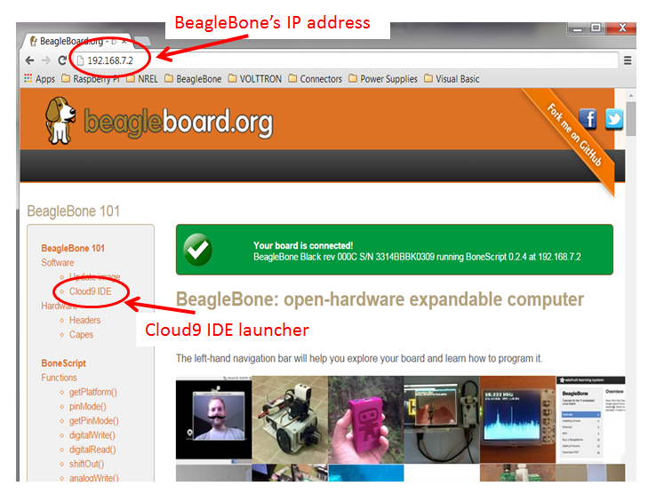

### Option 2: Your BeagleBone is wirelessly connected to the same network as your computer

1. With the external monitor, external USB hub – keyboard, mouse, and Wi-Fi dongle – setup, get the BeagleBone’s IP address.

click start 🡪 Internet 🡪 Wicd Network Manager

At the bottom of the dialog box, the BeagleBone’s IP address will be listed. Save this somewhere so you don’t always have to use the external monitor, keyboard, and mouse.

1. Enter the IP address, just found, into your web browser

>> 10.10.28.81 (for my case)

1. Open the Cloud 9 IDE (Figure X)

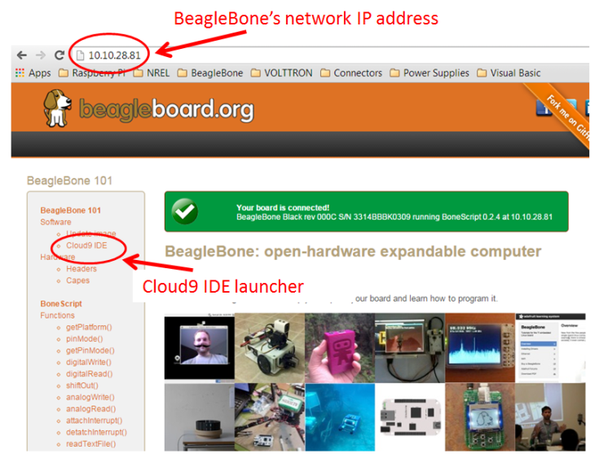

## Transferring Files between Laptop and BeagleBone

The following is for Windows. I am not sure how to do this on a Mac.

1. Follow the instructions [here](http://inspire.logicsupply.com/2014/08/beaglebone-file-transfer-using-winscp.html).

# Developing Agents and Using VOLTTRONTM

I developed my agents in [PyCharm](https://www.jetbrains.com/pycharm/download/) and then transferred them over to the BeagleBone using WinSCP (see section 6.4 and 8.4). When creating your agents follow the directory and naming scheme:

NewAgent (this is a directory)

new (this is a directory)

agent.py

__init__.py

setup.py

config.txt (optional)

The python module agent.py is what you develop. I recommend starting your development with an agent that already works, and then make your own modifications from there.

All agents that are developed should be transferred to the Agents directory within the main volttron directory on the BeagleBone (or virtual machine). In my case, this is the directory location:

/home/debian/volttron/Agents

Once agents have been transferred to the BeagleBone in the Agents directory you need to start VOLTTRON and then package, configure, and install them (see section 8.4).

If you change anything in the agent’s directory or code, you will need to repackage, configure, and install it. Otherwise, once the agents have been installed you never need to package them again. You can just start them.

To check what agents are installed, type the following once VOLTTRON has been activated and started.

>> volttron-ctl status

Once the agents are successfully installed you can start them:

>> volttron-ctl start --name newagent-0.1

To stop the agents:

>> volttron-ctl stop –name newagent-0.1

or

>> volttron-ctl shutdown (stops all agents that are running)

If you want to totally stop VOLTTRON you will need to reboot the BeagleBone or virtual machine. If you know how to kill a process, you could do that instead -- I don’t.

More information about using VOLTTRON and developing agents can be found on their [wiki](https://github.com/VOLTTRON/volttron/wiki/). They are currently working on a more comprehensive user guide.

# Experiment Guide

## Project Overview

A user connects to the BeagleBone with a laptop using the Cloud 9 IDE. With VOLTTRON and the agents running, a user sends commands telling the dehumidifier to turn on or off. Possible demand response commands are “run fan’, ‘shed fan’, ‘run dehum’, and ‘shed dehum’. The BeagleBone interprets whatever message it receives from the laptop and sets its general purpose output pins high or low, accordingly. Based on what the GPIO pins are set to, the relays are either opened or closed, and the fan and compressor turned on or off.

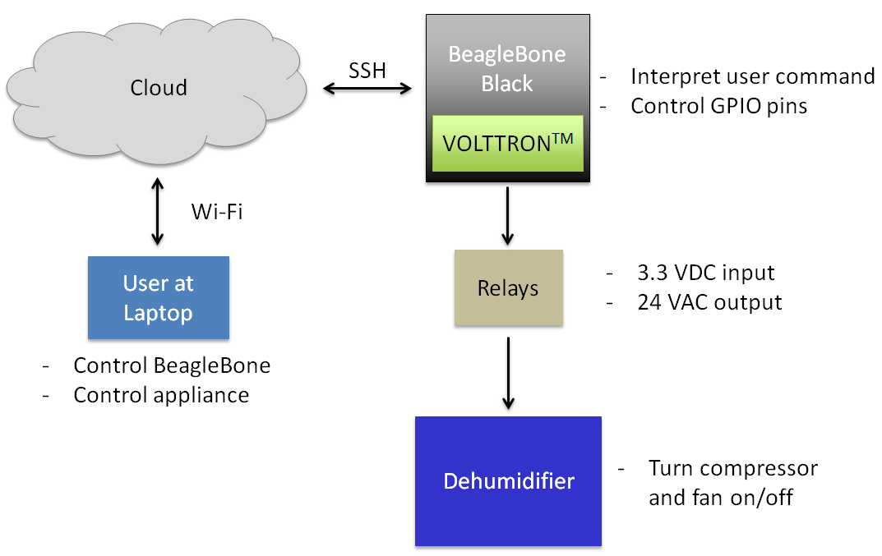

Functional description of each component of the project.

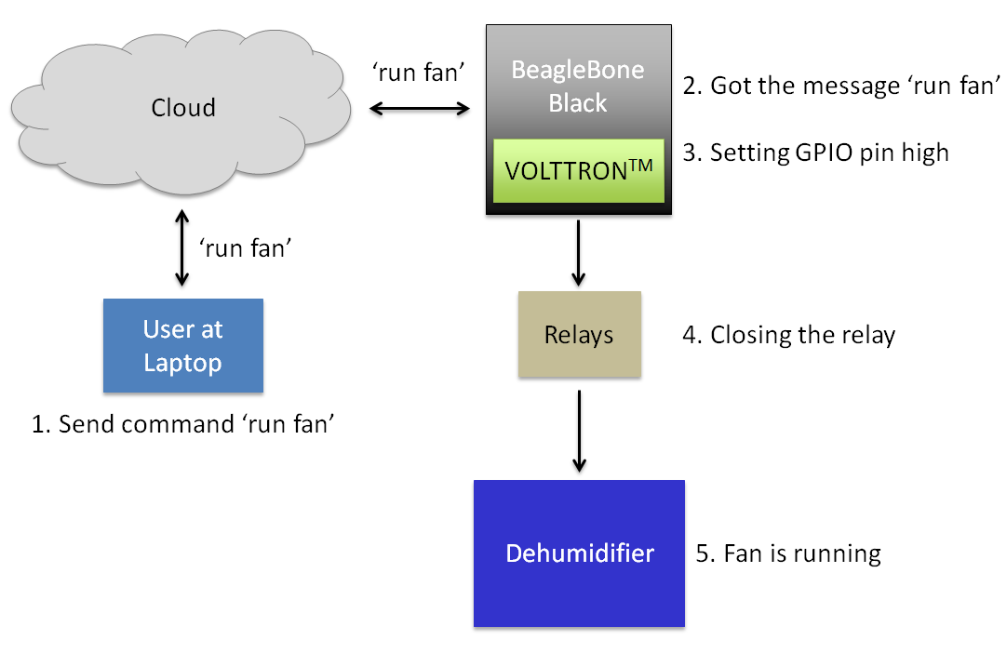

Flow of how the project works.

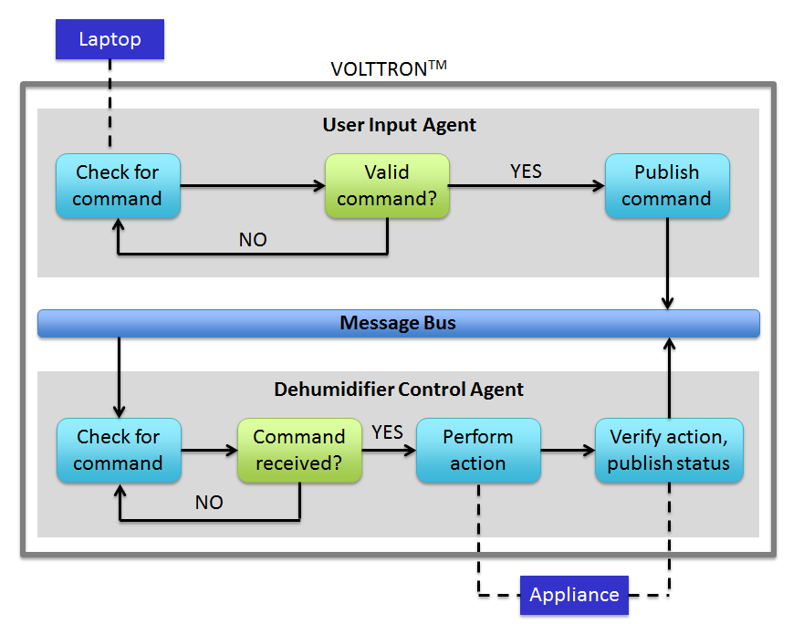

Flow diagram of the VOLTTRON agents that were developed.

## (Pre- Experimentation) Create Services That Run Automatically at Boot

Services direct the processor to run a Python script upon startup.

### Create Service that Sets GPIO Pins Low

This service is used so your BeagleBone doesn’t accidentally start an appliance when it is turned on.

1. Connect to the BeagleBone from your laptop over SSH, using the USB B port.
2. Create a directory to store your python scripts.

>> cd /home/debian

>> mkdir startAtBoot

1. Using WinSCP copy the file “dhsetup.py” in the network folder to /home/debian/startAtBoot/ on the BeagleBone
2. Create a directory to store your services

>> cd /home/debian

>> mkdir services

1. Using WinSCP copy the file “dhsetup.service” in the network folder to /home/debian/startAtBoot/services on the BeagleBone
2. Copy the “dhsetup.service” to a location that can be accessed by the kernel at boot

cd /home/debian/startAtBoot/services

cp dhsetup.service /lib/system/system

1. Check that the service works

>> cd /lib/systemd/system

>> systemctl enable dhsetup.service

>> systemctl start dhsetup.service

>> systemctl status dhsetup.service

You should see the following. Make sure you see SUCCESS as highlighted in red.

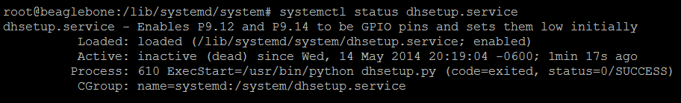

If successful, when you reboot the BeagleBone this service will automatically be performed, so you do not need to repeat step 7 again.

### Create Service that Updates Date and Time

This [tutorial](http://derekmolloy.ie/automatically-setting-the-beaglebone-black-time-using-ntp/) allows the BeagleBone’s date and time to be set upon startup. I did not have success with this because I was using NREL wireless, which requires user authentication each time you turn the BeagleBone on. However, if a hotspot is used, the BeagleBone should automatically connect to the correct network and update the time, so the above tutorial should work. Otherwise, you will need to update the date and time manually each time the BeagleBone is turned on:

>> ntpdate –b –s –u pool.ntp.org

Note: In the tutorial where it says ‘opkg’ you will need to use ‘sudo apt-get’ or just ‘apt-get’ if you are logged in as a root user.

## Hardware Setup

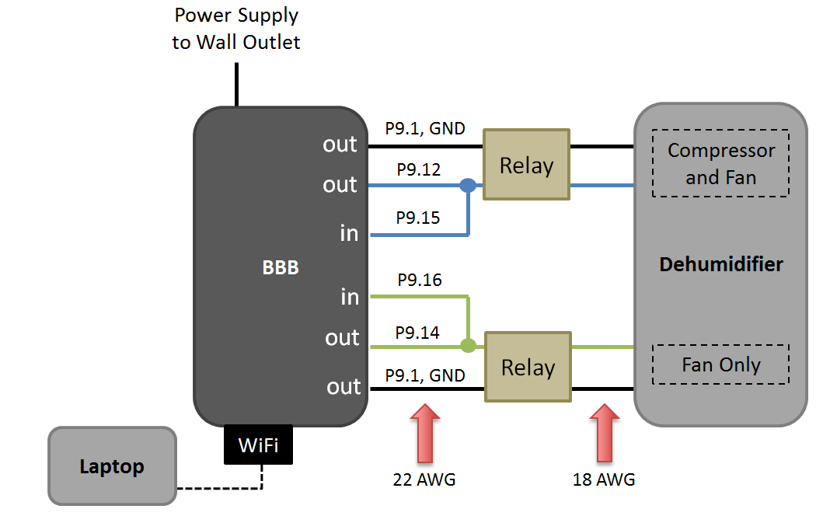

The Wi-Fi Dongle is plugged directly into the BeagleBone’s USB port. Power is supplied to the BeagleBone from a wall outlet via the 5VDC power supply. Pins from the BeagleBone are connected to the input terminals of two relays. Outputs of the relay are connected to the dehumidifier.

The two figures on the next page show the connections required from the relays to the dehumidifier.

The dehumidifier user manual is provided in the network folder.

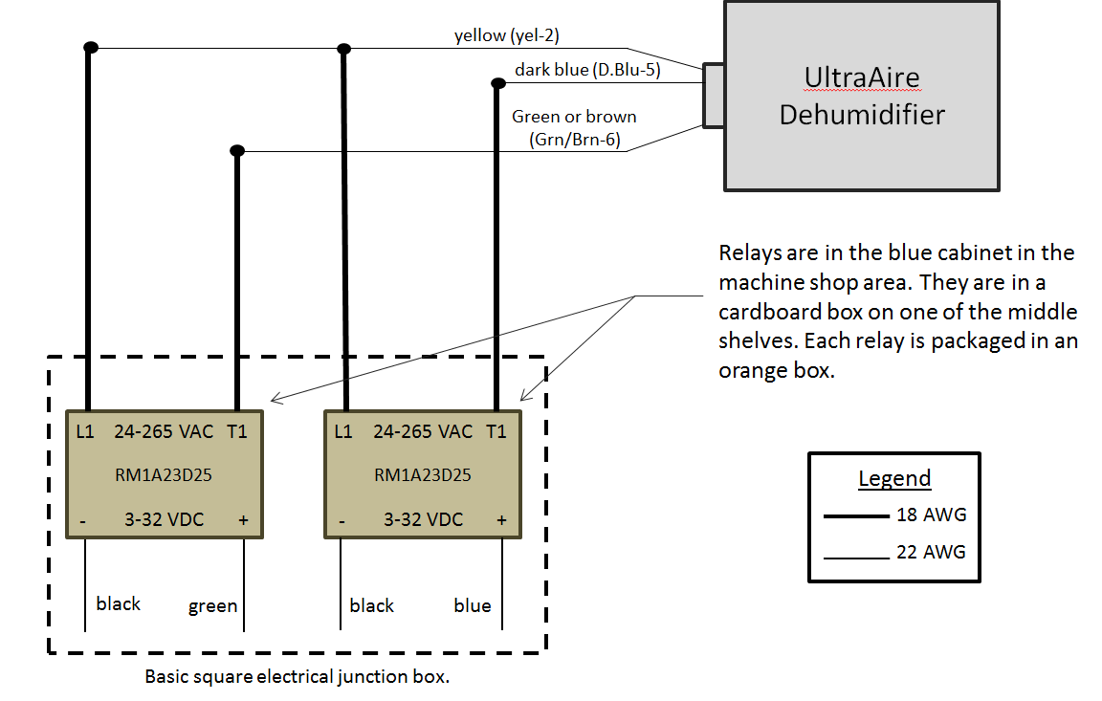

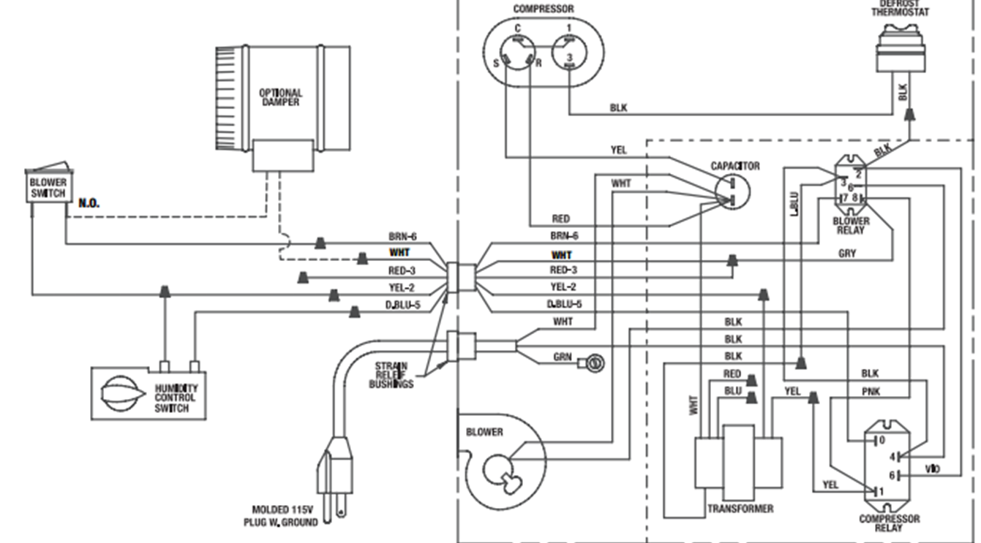

## Transfer Code for Agents to BeagleBone and Install the Agents

1. Connect to the BeagleBone from a laptop via USB.
2. Using WinSCP (see section 6.4) copy the folders titled “DHControlAgent” and “UserInputAgent” from the network folder to the BeagleBone /home/debian/volttron/Agents
3. Activate the VOLTRON virtual environment and start the platform

>> cd /home/debian/Volttron

>> . env/bin/activate (activate VOLTTRON virtual environment)

>> volttron –vv –l volttron.log& (start VOLTTRON platform)

1. On the BeagleBone (PuTTY terminal), package, configure, and install the agents

DH Control Agent

>> volttron-pkg package Agents/DHControlAgent

>> volttron-pkg configure /tmp/volttron_wheels/dhcontrolagent-0.1-py2-none-any.whl Agents/DHControlAgent/config

>> volttron-ctl install /tmp/volttron_wheels/dhcontrolagent-0.1-py2-none-any.whl

User Input Agent

>> volttron-pkg package Agents/UserInputAgent

>> volttron-pkg configure /tmp/volttron_wheels/userinputagent-0.1-py2-none-any.whl Agents/UserInputAgent/config

>> volttron-ctl install /tmp/volttron_wheels/userinputagent-0.1-py2-none-any.whl

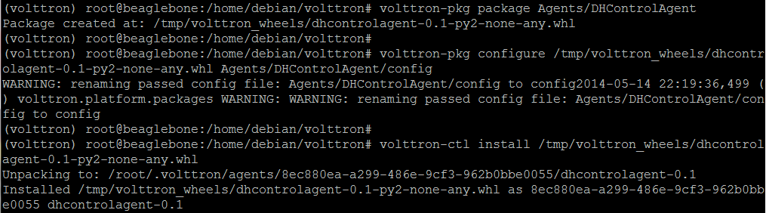

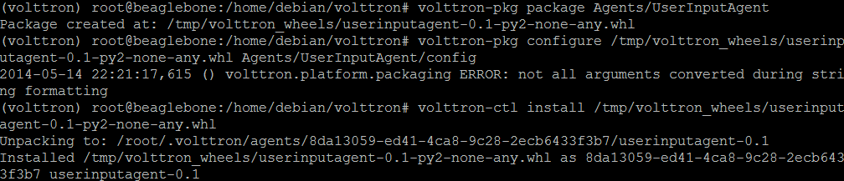

## Run Experiment

1. Plug in the appliance and BeagleBone.
2. Connect to the BeagleBone from a laptop, smartphone, or tablet by entering its IP address into a web browser and start Cloud 9.

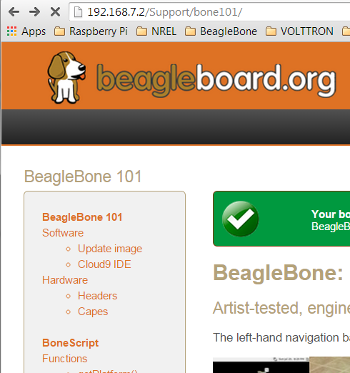 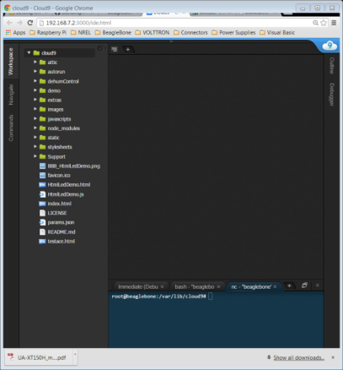

Enter IP address Cloud 9 IDE

1. Open a new terminal window in Cloud 9.

Click Window 🡪 New Terminal

or

press <Alt-T>

or

Click the + icon 🡪 New Terminal

1. Check that the date and time are correct.

>> cd

>> date

If not,

>> ntpdate –b –s –u pool.ntp.org

Then check if the date and time were updated.

>> date

1. Change the directory to wherever VOLTTRON lives. In this case,

cd /home/debian/volttron

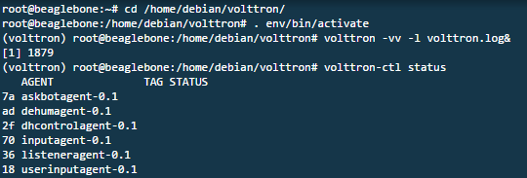

1. Activate the VOLTTRON virtual environment and start the VOLTTRON platform



1. Check what agents are installed.



The two agents we care about.

1. Start the dhcontrol agent first and then the userinput agent.

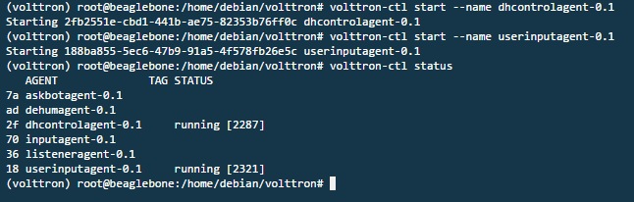

1. Verify that the agents are running.



1. Open a new terminal window in Cloud 9 (see step 1)
2. Connect to Netcat

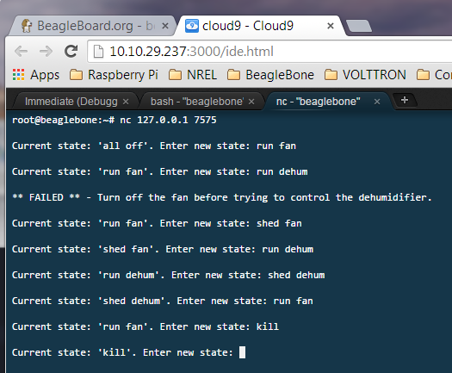

1. Enter a command as prompted. Allowed commands are:

run fan - turns on the fan only

shed fan – turns off the fan only

run dehum – turns on the compressor and fan

shed dehum – turns off the compressor and fan

status - in volttron log file shows whether dehumidifier and fan are on or off

kill – sets all GPIO pins lows, forcing the compressor and fan off

help – shows what the possible commands are



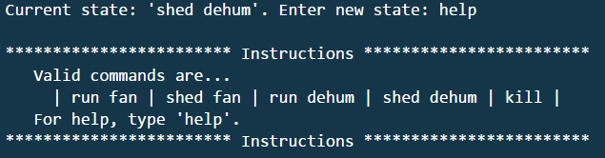

1. The log file keeps track of all actions that are performed. Check the log file to see if the appropriate actions were performed.

For the full log file type: cat volttron.log

For just the end of the log file type: tail volttron.log

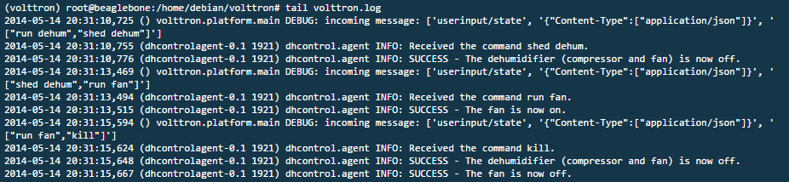

1. After typing the command ‘kill’, stop the agents by either stopping each one individually or by shutting VOLTTRON down. (Before exiting each agent, PyBBIO ensures that the GPIO pins are returned to the status they were before the program started, so the GPIO pins will be set low. However, it is best practice to shut down the components with the ‘kill’ command before stopping VOLTTRON.)

Stop agents individually:

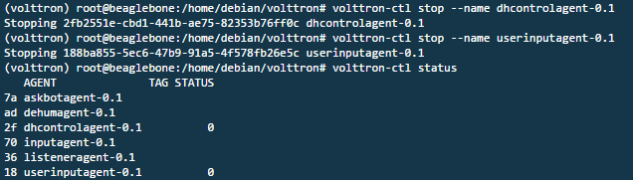

Shutdown VOLTTRON:

volttron-ctl shutdown

1. Verify agents are not running. If there is a 0 next to the agent, it means the agents were stopped successfully.



1. When you are all done with experimentation, shutdown the BeagleBone and unplug the dehumidifier.

>> shutdown –h now